Validating Generative AI as an Automated Writing Evaluation Tool: Assessing ChatGPT's Accuracy and Formative Feedback in Malaysian Matriculation MUET Essay Writing
Chan Kin Wei & Shafiq bin Rasulan
Kolej Matrikulasi Sarawak, Kuching, Sarawak, Malaysia

ABSTRACT
Writing is the most persistent barrier to Band improvement in the Malaysian University English Test (MUET), and grading latency in conventional classrooms delays the formative feedback students need to revise effectively. This action research, conducted at Kolej Matrikulasi Sarawak under the Kanvas Model Transformasi Sekolah (KMTS) FACES framework, examined whether ChatGPT can function as a valid, efficient Automated Writing Evaluation (AWE) tool for MUET Writing Paper 800/4. Baseline data showed 69% of 208 matriculation students scored Band 3 or below in writing, with a focal sample of 40 students returning a comparable 47.5% at Band 3 or below. Over three months, students handwrote timed essays, digitized them via Google Lens OCR, and submitted them to structured ChatGPT prompts (CEFR B2-anchored grading, sentence-level grammar checks) for same-day feedback, before reconstructing and re-evaluating their actual MUET exam essays. Scoring concordance between ChatGPT and official MUET examiners reached a 95% exact Band match (38 of 40 students), with 5% (n = 2) showing minor variance of ±0.5 Band. Band 4-and-above attainment moved from 17.5% (baseline) to 22.5% (AI-assisted practice) before settling at 12.5% in the actual examination. Findings indicate that prompt-guided generative AI can approximate rater-level accuracy while compressing feedback turnaround from days to hours, supporting Zone of Proximal Development scaffolding, Assessment for Learning, and self-regulated iterative writing practice. Implications for lecturer workload, scaling strategies, and study limitations are discussed.
Keywords: Generative AI; Automated Writing Evaluation; MUET Writing; Formative Feedback
INTRODUCTION
Writing proficiency is the single most consequential and most difficult skill for Malaysian matriculation students to master en route to university admission, because it disproportionately determines whether a candidate secures a competitive MUET overall Band. Institutional data from Kolej Matrikulasi Sarawak illustrate the scale of the problem. Across the 2024/2025 session, the overall MUET cohort of 208 matriculation students was dominated by Band 4 performance; however, when writing (Paper 800/4) was isolated as a discrete skill, 69% of the same 208 students scored Band 3 or below. A subsequent focal sample of 40 students sitting the 800/4 Session 1 2025 MUET paper echoed this pattern, with the majority clustering at Band 3.5, a meaningful number at Band 3 or 2.5, and only a handful reaching Band 4 or above, translating to 47.5% of the sample at Band 3 or below.
This writing deficit is compounded by a structural bottleneck: grading latency. Manual marking of large matriculation cohorts requires lecturers to devote extensive out-of-class hours to reading, scoring, and annotating handwritten scripts, so students typically wait several days before receiving feedback. By the time feedback arrives, the cognitive and motivational context in which the essay was produced has often faded, undermining students' ability to act on it. This gap between the pedagogical ideal of immediate, formative feedback and the practical constraints of manual grading is the central problem this study addresses.
Research Objectives
This study aims to: (i) determine the scoring concordance between ChatGPT-generated evaluations and official MUET examiner writing Band scores; (ii) examine how real-time AI formative feedback influences student essay performance across iterative practice sessions; and (iii) evaluate the viability of integrating OCR digitizing tools (Google Lens) with structured prompts for same-day writing evaluation in L2 classrooms.
Research Questions
- RQ1 (Accuracy): What is the scoring concordance between ChatGPT-generated evaluations and official MUET examiner writing Band scores?
- RQ2 (Longitudinal Impact): How does real-time AI formative feedback influence student essay performance across iterative practice sessions?
- RQ3 (Viability): How viable is the integration of OCR digitizing tools (Google Lens) and structured prompts for same-day writing evaluation in L2 classrooms?
Literature Review
Three overlapping strands of recent scholarship (2022–2026) bear on the present study: evidence on generative AI's accuracy as an essay-scoring instrument, evidence on its effectiveness as a formative feedback source, and the still-thin but rapidly growing body of Malaysian and regional research on AI-assisted ESL writing. Read together, they point less to a single verdict on “whether ChatGPT works” than to a converging, conditional picture: accuracy and instructional value both rise sharply when the tool is constrained by explicit criteria, and both remain understudied at the specific point where Malaysian matriculation students prepare for a single, high-stakes gatekeeping writing exam.
On scoring accuracy, the international evidence is consistently positive in direction but variable in magnitude, and the variability itself is informative. Mizumoto and Eguchi (2023), scoring 12,100 TOEFL11 essays with a GPT-based model, and Manning et al. (2025), comparing ChatGPT3.5/4 against trained raters, both report a meaningful but incomplete level of agreement with human scores, generally in the moderate range rather than near-exact. Where concordance climbs closer to expert-level agreement, it tends to do so under tightly specified conditions: Quah et al. (2024) obtained strong-to-moderate correlations between ChatGPT-4 and human examiners only once a detailed assessment rubric was supplied, and Poole and Coss (2024) show directly that ChatGPT's ability to apply a rubric to L2 writing depends less on the model itself than on how the prompt is engineered. Uyar and Büyükahıska (2025) reach a parallel conclusion, framing ChatGPT as viable specifically as a criterion-anchored AES tool rather than an open-ended judge of essay quality. Set against this pattern, Yamashita (2025) offers an important counterweight, documenting systematic biases in GPT-4o's ratings of English language learners' essays that persisted even under structured conditions, a reminder that rubric specificity narrows but does not eliminate scoring risk. Taken as a set, this literature suggests that near-perfect concordance is achievable but is the exception rather than the norm, and is most plausible precisely under the kind of narrow, Band-anchored, single-criterion prompting used in the present study.
On formative use, the picture is more genuinely mixed rather than simply cautious. Steiss et al. (2024), in the most methodologically rigorous comparison to date, scored 200 matched instances of human and ChatGPT feedback on secondary students' essays and found that trained human raters outperformed ChatGPT on four of five quality dimensions, with ChatGPT competitive only on criteria-based alignment; the authors nonetheless concluded that AI feedback remains useful where time-savings and feedback volume matter more than peak quality. In contrast, intervention studies that examine downstream student outcomes rather than feedback quality in isolation report more consistently positive effects: Meyer et al. (2024), in a randomized controlled trial with 459 German secondary students, found that GPT-3.5-generated feedback significantly increased text revision, motivation, and positive affect relative to no AI feedback. The apparent tension between these two strands, feedback that is measurably less polished than a trained teacher's yet still moves students to revise more and feel better about doing so, is consistent with the Assessment for Learning and Self-Regulated Learning rationale for this study: the operative advantage of AI feedback may lie less in matching human sophistication and more in its immediacy and its capacity to sustain iterative practice.
Within Malaysia specifically, AI-assisted English writing instruction has become an active research area only very recently, and almost entirely outside the matriculation/MUET context. Ooi et al. (2026) examined Form 2 secondary students' perceptions of GeniusWrite, an AI-integrated writing module developed under the Ministry of Education's Digital Educational Learning Initiative, and Sharmithashini and Hashim (2026) similarly found that AI-powered writing tools improved perceived grammar accuracy, vocabulary range, and revision autonomy among secondary ESL learners in a Kuala Lumpur international school, while flagging a moderate degree of tool dependence. At the secondary level in Johor Bahru, Ling and Salam (2025) found that Form 4 students needed a purpose-built scaffold (“Bard G”) to use generative AI productively for essay writing, citing gaps in digital literacy and guidance as key barriers, a finding that echoes this study's decision to constrain ChatGPT with three fixed prompts rather than open-ended use. Closest in learner profile to the present sample, Awaludin et al. (2025) surveyed 120 pre-university and undergraduate ESL students at a UiTM branch campus on their use of ChatGPT, Grammarly, QuillBot, and Google Translate, and reported strong perceived gains in writing performance and engagement, tempered by concerns about overdependence and limited critical evaluation of AI output. The only MUET-specific precedent, Ng et al. (2016), proposed a purpose-built Automated Essay Scoring Feedback (AESF) system for MUET writing preparation, arguing that rule-based computational support was needed given how demanding essay marking and feedback provision are in Malaysia's second-language classrooms; that proposal, however, predates the emergence of general-purpose large language models by several years.
Reading these three strands together identifies the gap this study addresses. The accuracy literature shows that near-exact AI–examiner concordance is achievable but rare and condition-dependent; the formative-feedback literature shows that AI feedback can drive engagement and revision even where its raw quality trails a trained teacher's; and the Malaysian literature shows growing but still secondary-school- and undergraduate-weighted interest in AI-assisted ESL writing, with no identified peer-reviewed study evaluating a general-purpose generative AI tool against official MUET examiner Band scores at the matriculation level, nor pairing such evaluation with a low-cost OCR digitization workflow. The present study is positioned to test, in this specific and previously unexamined setting, whether the conditions under which the international literature reports its strongest concordance results (narrow, criterion-anchored, Band-referenced prompting) can be replicated with an ordinary matriculation cohort using freely accessible tools.
Theoretical Framework
Four complementary theories frame this intervention. Vygotsky's (1978) Zone of Proximal Development (ZPD) and scaffolding theory position ChatGPT as a digital “More Knowledgeable Other” (MKO), supplying targeted micro-level corrections within the learner's zone of proximal development. Black and Wiliam's (1998) work on Assessment for Learning (AfL) underlines the value of feedback that arrives while learning is still actionable, motivating the intervention's same-session feedback design. Zimmerman's (2000) Self-Regulated Learning (SRL) model frames students' engagement across forethought, performance monitoring, and self-reflection phases. Flower and Hayes's (1981) Process Writing Approach reframes essay writing as an iterative, multi-draft cognitive task rather than a single summative product, consistent with the repeated write–digitize–evaluate cycle used in this study.
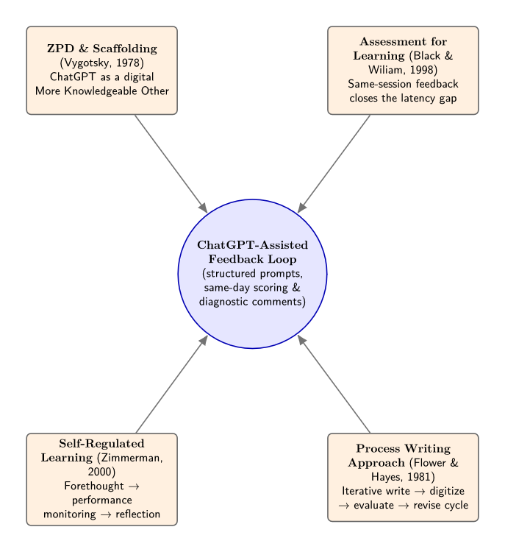
Figure 1: Conceptual diagram integrating the four guiding theories (ZPD/MKO scaffolding, AfL feedback loop, SRL cycle, and the Process Writing draft–revise loop) around the ChatGPT-assisted feedback workflow. To be inserted by the author.
METHODOLOGY
Research Design
This study adopted an action research design implemented through the Kanvas Model Transformasi Sekolah (KMTS) FACES framework (Find, Analyze, Curate, Execute, Sustain), a structured school-improvement planning tool used within the Talent in Leadership (TIL) coaching programme. The intervention was implemented by one PSELF lecturer (Chan Kin Wei) with support from one buddy/superior colleague (Shafiq bin Rasulan) at Kolej Matrikulasi Sarawak, Kuching, over an implementation period of approximately three months (April–June 2026).
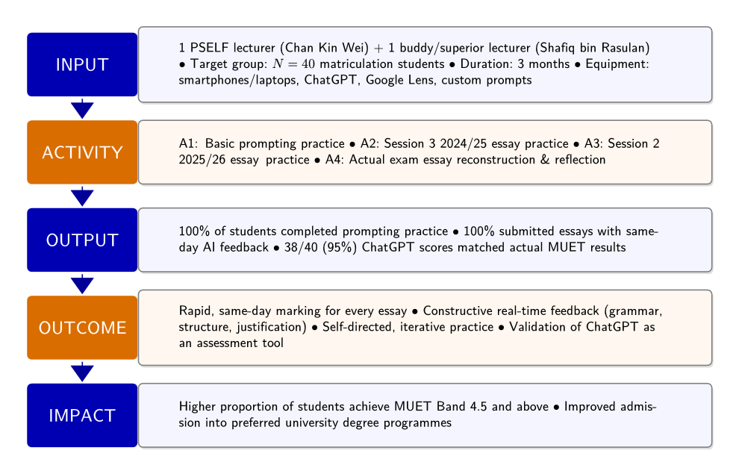
Figure 2: KMTS FACES Logic Model (Input → Activity → Output → Outcome → Impact), summarizing implementation personnel, target group, duration, and equipment against the four intervention activities and their outputs, outcomes, and impact goals. Source: KMTS TIL project planning documentation. To be inserted by the author.
Sampling
A purposive sample of N = 40 matriculation students was drawn from a 167-student cohort at the college (itself part of a larger 208-student MUET cohort). The sample was selected on the basis of availability for the 800/4 Session 1 2025 MUET writing paper and continued participation across all subsequent intervention phases.
Instruments
Instruments comprised: (i) three official MUET writing examination papers (Session 3 2024/2025, Session 2 2025/2026, and the actual Session 3 2025/2026 examination); (ii) Google Lens, used for optical character recognition (OCR) digitization of handwritten scripts; and (iii) a set of three structured ChatGPT prompts, namely “Grade my essay based on MUET pitch at B2 level,” “Check my grammar sentence by sentence,” and “Improve my essay to B2 level,” used consistently across all evaluation cycles.
Data Collection Procedures
The intervention followed a structured, multi-phase workflow. In Phase 1 (Activity 1), students were trained to use ChatGPT to evaluate three of their own essays using the structured prompt set, establishing procedural competence before graded practice. In Phase 2 (Activities 2 and 3), students completed handwritten essays under authentic examination conditions (1 hour 15 minutes) based on two official MUET papers in sequence; each essay was digitized via Google Lens OCR immediately after writing and submitted to ChatGPT using the same prompts, generating a Band score, error annotations, and improvement suggestions before the two-hour class session ended. In Phase 3 (Activity 4), two days after sitting the actual MUET Session 3 2025/2026 examination, all 40 students rewrote their examination essays from memory, digitized them via Google Lens, and evaluated them using the identical ChatGPT protocol, producing an AI-generated Band score directly comparable to each student's official MUET examiner score.
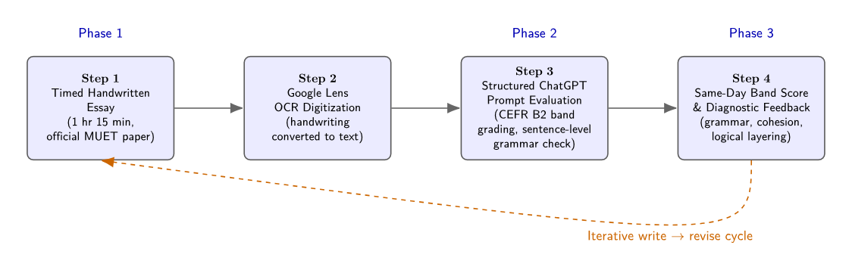
Figure 3: Three-phase intervention workflow diagram (timed handwritten essay → Google Lens OCR digitization → structured ChatGPT prompt evaluation → same-day Band score and diagnostic feedback), with representative screenshots of the digitized essay and ChatGPT interface. To be inserted by the author.
Across all four activities, completion rates were consistently high: 100% of the 40 students completed the prompting practice, and 100% submitted digitized essays with same-day AI feedback for the timed practice sessions. In the post-examination reconstruction phase, 38 of 40 students (95%) returned ChatGPT Band scores that matched their actual MUET results, forming the core accuracy dataset for RQ1.
Data Analysis
Percentage agreement between ChatGPT-generated Band scores and official MUET examiner scores was calculated as the proportion of exact Band matches versus scores showing minor variance (defined as a deviation of ±0.5 Band). Score distributions and variance were analyzed using Jamovi and Microsoft Excel, the latter also used to construct a color-coded tracking dashboard that visualized individual student Band shifts across successive writing sessions. Longitudinal performance across the three practice/examination phases was tracked as the percentage of the N = 40 sample achieving Band 4 and above at each phase.
RESEARCH FINDINGS
RQ1: Scoring Concordance Between ChatGPT and Official MUET Examiners
Concordance between ChatGPT-generated evaluations and official MUET examiner Band scores was high. Of the 40 students who reconstructed and resubmitted their actual examination essays, 38 (95%) received a ChatGPT Band score that was an exact match to their official MUET Band. The remaining 2 students (5%) showed a minor variance of ±0.5 Band between the AI-generated score and the official result.
Table 1: Summary of Score Concordance Between ChatGPT and Official MUET Examiners (N = 40)
Outcome Category | Students (n) | Percentage
Exact Band Match | 38 | 95%
Minor Variance (±0.5 Band) | 2 | 5%
Total | 40 | 100%
Note. Data derived from Activity 4 (post-examination essay reconstruction and re-evaluation).
Figure 4: ChatGPT Assessment Accuracy vs. Actual MUET Results (N = 40)
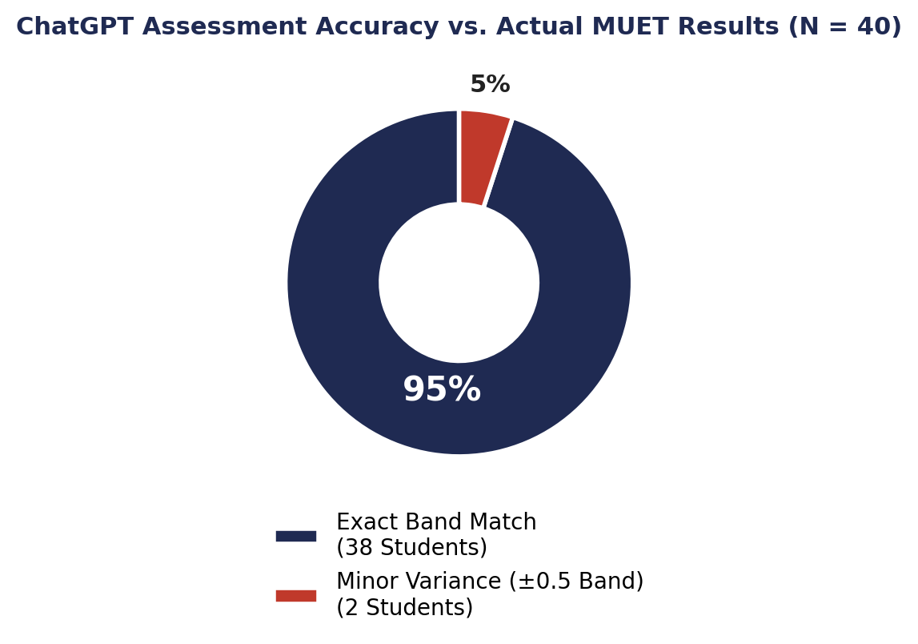
Note. Visual representation of Table 1.
RQ2: Longitudinal Progress Across Iterative Practice Sessions
Student attainment at Band 4 and above was tracked across three successive writing phases: the Session 1 2025 baseline essay, the Session 2 2025 essay produced after AI-assisted feedback practice, and the Session 3 2025 essay corresponding to the actual MUET examination.
Table 2: Percentage of Students (N = 40) Achieving Band 4 and Above Across Project Phases
Phase | Essay Source | % Achieving Band 4+ | n / N
Session 1 (Baseline) | Session 1 2025 Actual MUET Writing Paper | 17.5% | 7/40
Session 2 (AI Feedback Practice) | Session 2 2025 Actual MUET Writing Paper | 22.5% | 9/40
Session 3 (Actual Exam Output) | Session 3 2025 Actual MUET Writing Paper | 12.5% | 5/40
Note. Session 3 corresponds to performance on the actual, high-stakes MUET examination.
Figure 5: Student Achievement (Band 4.0 & Above) Across Project Phases
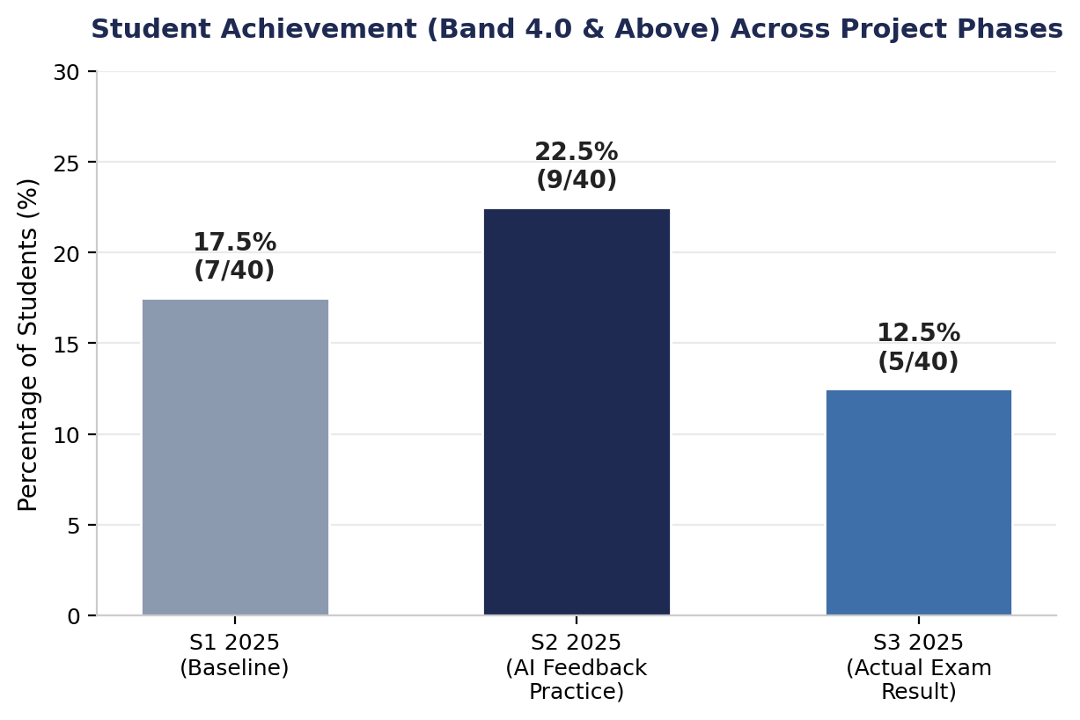
Note. Visual representation of Table 2.
Attainment rose by 5 percentage points from the baseline (17.5%) to the AI-assisted practice phase (22.5%), consistent with the hypothesized formative benefit of real-time feedback. However, performance on the actual, high-stakes examination (12.5%) fell below both prior phases, a pattern examined further in the Discussion section.
RQ3: Efficiency and Diagnostic Feedback Quality
The integration of Google Lens OCR digitization with structured ChatGPT prompts consistently enabled same-day turnaround: across all timed practice sessions, 100% of the 40 students received comprehensive AI feedback, including grammar correction, sentence-structure commentary, score justification, and actionable improvement suggestions, before the end of the same two-hour class period, eliminating the multi-day grading latency of conventional marking.
The diagnostic feedback generated by ChatGPT converged on a consistent set of barriers preventing students from advancing from high Band 4 to Band 5 performance, including: (1) generating distinct main ideas rather than repeating the same argument across different examples; (2) building paragraphs using a clear Point → Explain → Example → Explain the Example → Impact → Link sequence to strengthen logical layering; (3) selecting relevant supporting evidence that directly substantiates the main point; (4) developing more mature, analytical thinking by interrogating “why” and “so what” after each example; and (5) improving language accuracy, particularly subject–verb agreement, verb forms, prepositions, and collocations.
DISCUSSION AND CONCLUSION
Discussion
The 95% exact Band match rate (RQ1) situates this study at the favourable end of a literature whose central lesson is conditionality rather than a fixed verdict on AI scoring accuracy. Consistent with Quah et al. (2024) and Poole and Coss (2024), both of whom trace ChatGPT's scoring reliability primarily to rubric specificity and prompt engineering rather than to the underlying model, and with Uyar and Büyükahıska (2025), who likewise found ChatGPT viable as an AES tool once criteria were made explicit, the present concordance rate is best read as evidence that the narrow, Band-anchored, single-criterion prompt design used here sits close to the upper bound of what the wider literature considers achievable. It also updates Ng et al. (2016), whose MUET-specific AESF proposal called for purpose-built automated scoring software, by showing that a general-purpose generative AI tool, paired with commodity OCR, can approach that same goal without dedicated development. At the same time, the concordance rate reported here is markedly higher than the moderate agreement typically reported in the broader AES literature (e.g., Mizumoto & Eguchi, 2023; Manning et al., 2025), a gap that most plausibly reflects the narrower scope of the scoring task (a single Band judgment against a familiar national rubric) rather than a general superiority of ChatGPT as an evaluator, and it should be read alongside Yamashita's (2025) finding that GPT-4o ratings of English language learners' essays can carry systematic biases even under structured conditions, and against the modest, single-cohort sample on which the present result rests.
The longitudinal data (RQ2) and the diagnostic feedback findings (RQ3) sit within a formative-feedback literature that is more genuinely divided than the accuracy literature. Steiss et al. (2024), in the most rigorous available comparison, found that trained human raters outperformed ChatGPT on four of five formative feedback quality dimensions, with ChatGPT competitive mainly on criteria-based alignment, a finding that argues against treating AI feedback as a like-for-like substitute for expert marking. Yet Meyer et al. (2024), examining downstream student behaviour rather than feedback quality in isolation, found in a randomized trial that GPT-3.5 feedback significantly increased text revision, motivation, and positive affect among secondary students. The present study's pattern, rising Band 4+ attainment from baseline to AI-assisted practice (17.5% to 22.5%) despite feedback that was not independently benchmarked against expert markers, is more consistent with the Meyer et al. account: the operative mechanism may be less that ChatGPT feedback matches a trained lecturer's sophistication and more that it arrives immediately and sustains the iterative write-revise cycle central to Flower and Hayes's (1981) process writing approach. This same-session immediacy is also the mechanism through which Black and Wiliam's (1998) AfL principle and Vygotsky's (1978) ZPD/MKO framing operate here, and the planned move to individual Google Sites e-portfolios extends this into the self-reflection phase of Zimmerman's (2000) SRL cycle.
Positioned against Malaysian and regional evidence, the findings both corroborate and extend a still-thin local literature. The positive perceived gains in grammar accuracy and revision autonomy reported among Malaysian secondary ESL learners by Sharmithashini and Hashim (2026) and Ooi et al. (2026) are echoed here in the consistency of the diagnostic feedback categories (logical layering, evidence selection, subject-verb agreement) that ChatGPT surfaced across the sample; unlike those two studies, however, the present design adds an objective, examiner-referenced concordance check rather than relying on self-reported perceptions alone. Ling and Salam's (2025) finding that Johor Bahru secondary students needed a structured scaffold to use generative AI productively, rather than being left to use it unguided, mirrors this study's decision to constrain ChatGPT to three fixed prompts, and may help explain why the present sample did not exhibit the overdependence and limited critical evaluation that Awaludin et al. (2025) flagged among UiTM pre-university and undergraduate ESL students using a wider, less-structured toolkit (ChatGPT, Grammarly, QuillBot, and Google Translate together). Read as a set, this comparison suggests that the risk of overreliance on AI in Malaysian ESL writing instruction identified elsewhere in the literature is not inherent to the tools themselves but is moderated by how tightly the prompting protocol is scaffolded, an implication with direct bearing on how this intervention should be scaled.
Two patterns within the present data merit closer interpretation. First, the 5% (n = 2) of students whose ChatGPT-derived Band score diverged from their official result by ±0.5 Band appear to reflect post-exam recall and self-editing bias: because Activity 4 required students to reconstruct their examination essay from memory two days after sitting the actual test, some students plausibly refined phrasing or corrected errors before submitting the reconstructed text for AI evaluation, a limitation of the reconstruction methodology rather than evidence of AI scoring error. Second, the dip in Band 4+ attainment at the actual examination phase (12.5%) relative to the AI-assisted practice phase (22.5%) should not be read as evidence that the intervention was ineffective; actual MUET examinations carry higher performance stakes, tighter time pressure, and the absence of any in-task feedback loop, all of which plausibly suppress performance relative to a practice session in which students had just received, and could still apply, real-time diagnostic comments.
For lecturer workload, the demonstrated same-day turnaround suggests AI-assisted marking can substantially offset the manual grading burden associated with large matriculation cohorts, freeing lecturer time for higher-order feedback rather than first-pass error identification, a benefit consistent with Steiss et al.'s (2024) conclusion that AI feedback remains valuable on time-saving grounds even where its raw quality trails a trained teacher's. Several limitations constrain the generalizability of these findings: the sample size (N = 40) is modest and drawn from a single matriculation college; workflow accuracy is contingent on Google Lens OCR output clarity, which depends on handwriting legibility; and the post-exam essay reconstruction methodology used to generate the RQ1 comparison dataset introduces a recall-and-revision confound that a design using original exam scripts directly would avoid.
Conclusion and Recommendations
This action research study provides preliminary but encouraging evidence that generative AI, when guided by structured, criterion-referenced prompts, can serve as a reliable formative Automated Writing Evaluation tool for MUET Writing Paper 800/4. ChatGPT achieved a 95% exact Band match against official MUET examiner scores across a sample of 40 matriculation students, while enabling same-day feedback turnaround that is structurally difficult to achieve under conventional manual marking at scale. Longitudinal data suggest that AI-assisted iterative practice can produce measurable short-term gains in Band 4+ attainment, even as performance on the single high-stakes examination remained more constrained by testing conditions than by feedback quality.
Four scaling strategies are recommended for the 2026/2027 cohort and beyond, together with directions for future research:
- Cohort Expansion via a “Replicate and Duplicate” Model (July–October 2026): Extend the same structured workflow to the incoming 2026/2027 Semester 1 matriculation cohort over their four-month MUET preparation window.
- Google Sites Student E-Portfolios: Require each student to maintain an individual Google Sites portfolio logging weekly essays, ChatGPT evaluation reports, and revision iterations across a 16-week cycle.
- Integrated Speaking–Writing Skill Enhancement: Expand the structured prompt framework to incorporate MUET Speaking (800/2) alongside Writing (800/4) within combined interactive language sessions.
- Departmental Professional Learning Community (PLC) and Future Research: Sustain collaborative monitoring using the color-coded Excel tracking dashboard, and pursue larger, multi-institution replications that compare ChatGPT scoring directly against original examination scripts (rather than post-exam reconstructions) to remove the recall-bias confound identified in this study.
Collectively, these findings support the cautious but affirmative conclusion that prompt-guided generative AI can function as a valid, scalable, same-day formative assessment partner in L2 writing instruction, provided its use remains anchored to explicit scoring criteria, subject to periodic human validation, and embedded within a broader process-oriented pedagogy.
REFERENCES
Awaludin, F. A., Ahmad Junid, R., Zaidi, A., Che Ghani, N. F., Abd Karim, R., Ibrahim, N. A., & Norafand, N. N. (2025). Student engagement and perceptions of AI-powered tools in ESL learning: Effectiveness in higher education. International Journal of Research and Innovation in Social Science, 9(11), 3318–3330.
Black, P., & Wiliam, D. (1998). Assessment and classroom learning. Assessment in Education: Principles, Policy & Practice, 5(1), 7–74. https://doi.org/10.1080/0969595980050102
Flower, L., & Hayes, J. R. (1981). A cognitive process theory of writing. College Composition and Communication, 32(4), 365–387. https://doi.org/10.2307/356600
Ling, S. J., & Salam, A. R. (2025). Teaching secondary school essay writing using generative AI. International Journal of Research and Innovation in Social Science, 9(3S), 6065–6070.
Manning, J., Baldwin, J., & Powell, N. (2025). Human versus machine: The effectiveness of ChatGPT in automated essay scoring. Innovations in Education and Teaching International, 62(5), 1500–1513. https://doi.org/10.1080/14703297.2025.2469089
Meyer, J., Jansen, T., Schiller, R., Liebenow, L. W., Steinbach, M., Horbach, A., & Fleckenstein, J. (2024). Using LLMs to bring evidence-based feedback into the classroom: AI-generated feedback increases secondary students' text revision, motivation, and positive emotions. Computers and Education: Artificial Intelligence, 6, Article 100199. https://doi.org/10.1016/j.caeai.2023.100199
Mizumoto, A., & Eguchi, M. (2023). Exploring the potential of using an AI language model for automated essay scoring. Research Methods in Applied Linguistics, 2(2), Article 100050. https://doi.org/10.1016/j.rmal.2023.100050
Ng, S. Y., Bong, C. H., Lee, N. K., & Hong, K. S. (2016). Automated Essay Scoring Feedback (AESF): An innovative writing solution to the Malaysian University English Test (MUET). Penerbit UiTM (UiTM Press).
Ooi, Y. H., Yunus, M. M., & Said, N. E. M. (2026). Perceptions of Malaysian secondary school students on GeniusWrite, AI-integrated module for learning English writing. International Journal of Learning, Teaching and Educational Research, 25(6), 334–371.
Poole, F. J., & Coss, M. D. (2024). Can ChatGPT reliably and accurately apply a rubric to L2 writing assessments? The devil is in the prompt(s). Journal of Technology and Chinese Language Teaching, 15(1), 1–24.
Quah, B., Zheng, L., Sng, T. J. H., Yong, C. W., & Islam, I. (2024). Reliability of ChatGPT in automated essay scoring for dental undergraduate examinations. BMC Medical Education, 24(1), Article 962. https://doi.org/10.1186/s12909-024-05881-6
Sharmithashini, M., & Hashim, H. (2026). Enhancing secondary ESL students' writing proficiency with AI-powered writing tools: An empirical study. International Journal of Research and Innovation in Social Science, 13(1). https://doi.org/10.51244/IJRSI.2026.13010220
Steiss, J., Tate, T., Graham, S., Cruz, J., Hebert, M., Wang, J., Moon, Y., Tseng, W., Warschauer, M., & Olson, C. B. (2024). Comparing the quality of human and ChatGPT feedback of students' writing. Learning and Instruction, 91, Article 101894. https://doi.org/10.1016/j.learninstruc.2024.101894
Uyar, A. C., & Büyükahıska, D. (2025). Artificial intelligence as an automated essay scoring tool: A focus on ChatGPT. International Journal of Assessment Tools in Education, 12(1), 20–32.
Vygotsky, L. S. (1978). Mind in society: The development of higher psychological processes. Harvard University Press.
Yamashita, T. (2025). Exploring potential biases in GPT-4o's ratings of English language learners' essays. Language Testing, 42(3), 344–358.
Zimmerman, B. J. (2000). Attaining self-regulation: A social cognitive perspective. In M. Boekaerts, P. R. Pintrich, & M. Zeidner (Eds.), Handbook of self-regulation (pp. 13–39). Academic Press.

